NSA-BRAZILIAN CAMP Registration Form COST: 195.00

Last name _____________________________ First name ________________________________

Birthday ___________ Gender: male__ female__ Shirt size AL AM AS YL YS

PARENT-Guardian E-mail _____________________________Telephone- ________________
ADDRESS ____________________________ CITY ________________ STATE_____ ZIP________

List any Medical Problem or prohibition player has__________________________________________
Person to notify in emergency _________________________________ Phone ____________________
Physician to notify in emergency _______________________________ Phone ____________________
HEALTH & ACCIDENT INSURANCE PROVIDER _______________________________________
Number of years played ______ Last team __________________ Last League ___________________
I, ________________________________ , the parent/guardian of the registrant, a minor, agree that I and the registrant will abide by the rules of the National Soccer Academy (NSA), its affiliated organizations and sponsors. Recognizing the possibility of physical injury associated with soccer and in consideration for NSA accepting the registrant for its soccer programs and activities (the "Programs"), I hereby release, discharge and/or otherwise indemnify NSA, its affiliated organizations and sponsors, their directors, employees and associated personnel, including the owners of fields and facilities utilized for the Programs, against any claim by or on behalf of the registrant as a result of the registrant's participation in the Programs and/or being transported to or from the same, which transportation I hereby authorize. I also certify that my child is covered by primary health insurance for all injuries that may result from the "PROGRAMS". I acknowledge that NSA does not provide health and accident insurance for participants in any of its "PROGRAMS".

CONSENT FOR MEDICAL TREATMENT (MINOR)
As the parent/legal guardian of the above-named registrant, I hereby give consent for emergency care prescribed by a duly licensed Doctor of Medicine or Doctor of Dentistry. This care may be given under whatever conditions necessary to preserve the life, limb or well-being of my dependent.

NAME____________________________ Signature:____________________________________
Parent/legal Guardian (Please Print)
Occupation:__________________________________

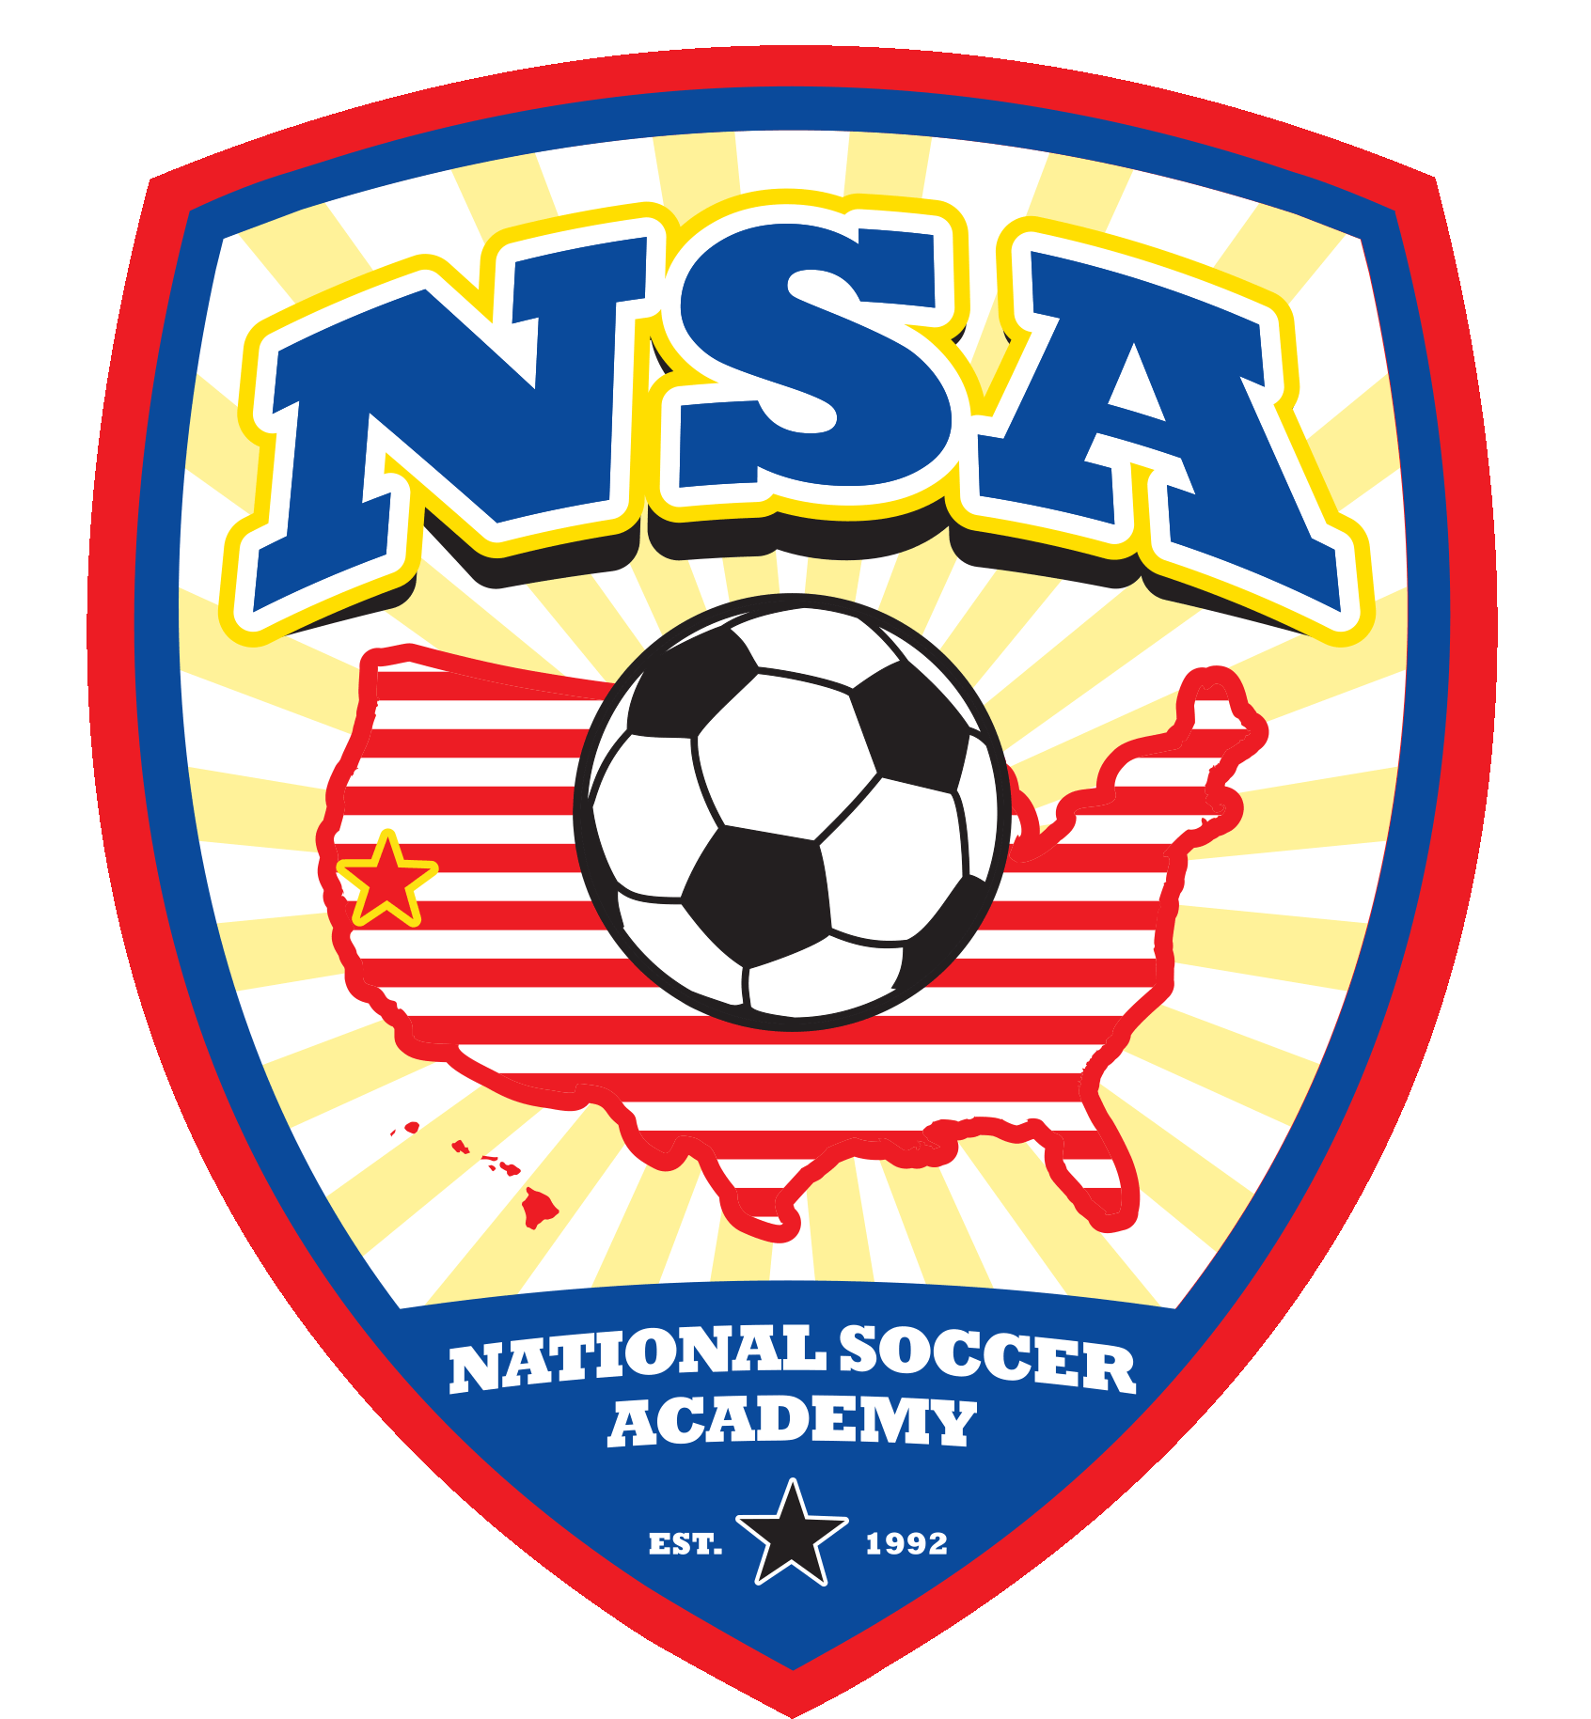 | NSA  26230 Road 97, Davis, CA 95616  E-mail: nsaguru@gmail.com website: www.nationalsocceracademy.com | 

USE ZELLE to do free bank to bank transfer , SEND TO nsaguru@gmail.com
Mail check to NSA 26230 County Road. 97, Davis , CA 95616
USE VENMO, SEND TO @Fred-NSA

