 | Objectives of the NSA Training/tryout sessions  www.nationalsocceracademy.org | 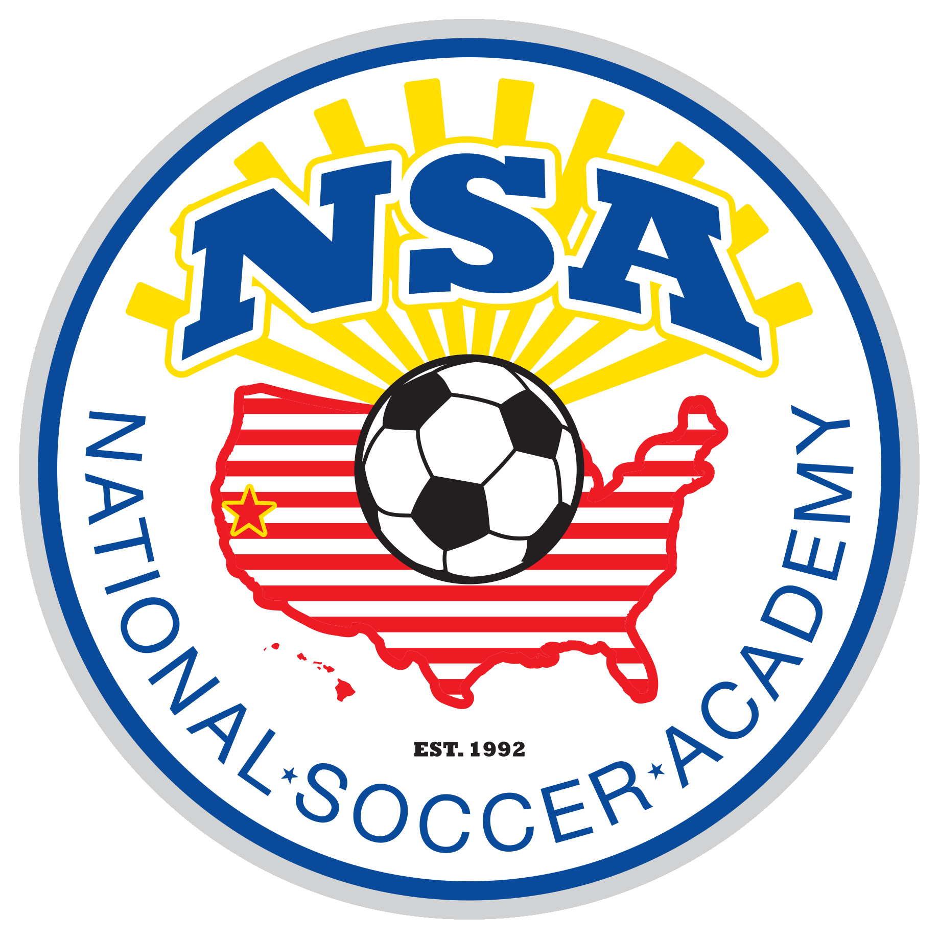
The NSA EuroTour mission is “to use soccer as a catalyst in bringing people together and enjoy cultural exchange experiences”. Through this process, we aim to help foster new friendships and create life long memories.
1. Please RELAX … this is more a TRAINING session then a tryout. This is the opportunity for you to find out more about NSA and for the NSA coaches to share some knowledge. You can expect players of different ages and gender training together. Since we are selecting players from many different locations, the number of players coming to each training session will vary. We will run many different “Organized Chaos” exercises. You will be in an environment where you can be yourself, play and enjoy. At the end of the session, we will have a good idea if you will benefit from our program.
2. NSA International Tours: This is a major commitment. Please review the NSA website for details, especially costs so there are no surprises. We want you to have time to plan for the tour. As soon as you are invited, please make your commitment and plan ahead.
3. Communication: The serious players who want more with supportive families will be invited to participate on NSA tournament teams. It is important we have accurate contact information. If for some reason you do not hear from us, please do not hesitate to contact Coach Fred nsaguru@gmail.com 530-400-1903
4. NSA Local Tournament teams: when we see enough of a group for a special event in the USA, we will invite players to participate. See the website for details. NSA players will register with US Club Soccer under NSA for their player pass. NSA is one of the few Academies that US Club Soccer has granted the right to Dual Register players. This means you can register with NSA and your local club (which we want you to stay with). This will avoid issues when it comes time to participate with NSA in tournaments.
5. College Bound Player Guidance Program: for 7th, 8th 9th 10th grade student athletes who have the ability and ambition to play college soccer. Please visit the NSA website for more details.
6. Stay with your own Club: NSA offers programs for those who want more than what their local team offers. However, we are NOT a local club and we only hold training sessions several times a month. Before a tournament, we will have intense training sessions. Therefore, it is critical you play with a local club close to where you live , learn and stay in top shape.
7. NSA Training T-shirt: please wear an NSA Training T-shirt at all training sessions (you may purchase one online and they will be delivered at the session). Bring your Soccer Ball, Water and Dress Ready to play.
Date: __________ NSA Medical Release Form Birthday ____________

Last name ________________________________First name ___________________________________ male____female____

Email:_____________________________________________________________ Cell Phone:__________________________________

ADDRESS ______________________________________ CITY ___________________________ STATE_____ ZIP________________

Parents/Guardian names:__________________________________________E-mail_____________________________________

List any Medical Problem or prohibition player has__________________________________________________________

Person to notify in emergency _____________________________________________________ Phone ____________________

Physician to notify in emergency __________________________________________________ Phone ____________________

HEALTH & ACCIDENT INSURANCE PROVIDER ______________________________________________________________

Number of years played ______ Last team ________________________ Last Club ___________________________________

I, ________________________________ , the parent/guardian of the registrant, a minor, agree that I and the registrant will abide by the rules of the National Soccer Academy (NSA), its affiliated organizations and sponsors. Recognizing the possibility of physical injury associated with soccer and in consideration for NSA accepting the registrant for its soccer programs and activities (the "Programs"), I hereby release, discharge and/or otherwise indemnify NSA, its affiliated organizations and sponsors, their directors, employees and associated personnel, including the owners of fields and facilities utilized for the Programs, against any claim by or on behalf of the registrant as a result of the registrant's participation in the Programs and/or being transported to or from the same, which transportation I hereby authorize. I also certify that my child is covered by primary health insurance for all injuries that may result from the "PROGRAMS". I acknowledge that NSA does not provide health and accident insurance for participants in any of its "PROGRAMS".

CONSENT FOR MEDICAL TREATMENT (MINOR)
As the parent/legal guardian of the above-named registrant, I hereby give consent for emergency care prescribed by a duly licensed Doctor of Medicine or Doctor of Dentistry. This care may be given under whatever conditions necessary to preserve the life, limb or well-being of my dependent.

NAME___________________________________ ______Signature:____________________________________
Parent/legal Guardian (Please Print)

Occupation:_____________________________________________________________
What is the process of joining tournament teams ?

- Come to an NSA training/tryout session
- Let NSA know whether you wish to participate in (local events, International tours or both).
- Be yourself at training;
- Logistics are different for every event, details will be sent with the invitation for that event.
- Come to the mandatory training sessions immediately prior to the event,
- Have fun , learn and make new friends.

What exactly is the selection process?

Players are observed during the NSA Training/tryout sessions.
Player Selection: Players are selected to join the NSA Tournament teams (Local and International) based on
- the players ability, motivation and passion for the game
- whether the NSA staff feels that the player can benefit from the NSA method of teaching.
- players having supportive parents who share the NSA philosophy of youth development and are willing to abide by the NSA guidelines
- Players ARE NOT selected simply because they are financially able to join NSA tours.
- NSA trains players to compete internationally. NSA is not a travel agency.
- Coaches Recommendations: Coaches of COMP level teams, Select or Classic teams and other higher level teams, please recommend players whom you think will benefit from the NSA Programs. They will come back to your team better players.

Is there a NSA tournament team player pool?
Yes, we keep a database of players from different areas and States who participate in NSA Camps and Clinics and have shown interest in Local and international tours.
During most training sessions, we will have players of both genders and a wide age range training together.
Immediately prior to a local tournament, we will have the tournament team come together for a sleep over weekend for intense tactical training. For the International Tour, we will have a 1 week of intense training prior to competing,

At which point in time do we get feedback from you on specific players who attended?
Normally within one or two days after the training, we will send invitations to players. However, sometimes we have incorrect emails. Therefore, if you do not receive communication from us, be sure to be proactive and contact coach Fred nsaguru@gmail.com.

Where are NSA teams based since logistics may impact participation?
Although NSA’s address is in Davis, CA; we move our training sessions to accommodate players from different locations. That is how we can reach the more serious players from many States to bring them together. We normally schedule the training sessions on Sundays late afternoon to minimize conflicts. Except for the intense training immediately prior to a tournament, the training sessions are open to those who can and wish to learn from us. Though not mandatory, many players find NSA to be beneficial and make our training days a priority.

Why come to NSA when you are already on a local team?
- To learn the NSA Style, on and off the field;
- To have like minded teammates
- To make new friends
- To participate in the International Soccer tours—a life changing experience.

Over the past 30 years of working with youth soccer programs, we have noticed that on every team, there seems to be always a few players who want more than what the local program offers. These are the players NSA provide Training services for. NSA teaches a “Possession Opportunistic Attack Style” of soccer that has enabled players to win many major championships for over 20 years.
By assembling teams of like minded players from different areas, different states and different countries, NSA provides excellent learning environment and rich cultural exchange experiences through Soccer.

We are NOT a local club and we only hold training sessions several times a month. Before a tournament, we will have intense training sessions. Therefore, it is critical you play with a local club close to where you live , learn and stay in top shape.

Registration : NSA is one of the few Academies that US Club Soccer has granted the right to Dual Register players. This means you can register with NSA and your local club (which we want you to stay with). This will avoid issues when it comes time to participate with NSA in tournaments.

Who is REALLY teaching your child?
When you come to NSA, Coach Fred takes a personal interest in all the players and is the head coach for all the tournament teams. Other qualified NSA staff will assist during training. During tournaments, additional NSA staff will be assigned to help manage the teams.

What are the events NSA participates in?
Every Summer , in July, we go on the International Tour to Denmark and Sweden.
Please visit the NSA website for the list USA tournaments we consider going to annually.
Other events will be considered based on the participants playing levels and desire.

Our objective is to teach.

