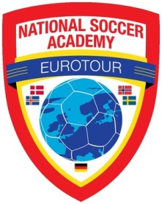**NSA EUROTOUR 2016 - Tryouts coming to Reno NV.**

**Youth Soccer should be a memorable experience!!**

**The NSA International Tour provides serious players with an experience of a lifetime.**

**Come join the excitement.**

**Sunday, October 11, 2015 1:00 - 3:00 PM**

Moana Park 240 West Moana Lane, Reno, NV,   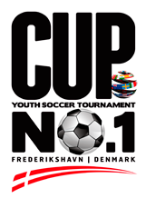

**The 24th annual NSA tour in 2016 will be from**

**July 8 to July 31, 2016**

**for serious players, boys and girls born 1999 to 2006.**

**Visit Iceland, Sweden, Denmark, Norway!**

1. **Week #1: sightseeing trip, Iceland, followed by Training and Cup No 1.**
2. **Week #2: Gothia Cup week (over 1750 teams from 75 nations)**
3. **Week #3: Dana Cup week (over 1050 teams from 50 nations)**

**Review Details and Register for tryout at [www.nationalsocceracademy.org](http://www.nationalsocceracademy.org)**

**Contact: Fred Hsu - USSF A Licensed, Brazilian Coaching License, USSF National Youth License** [**nsaguru@gmail.com**](mailto:nsaguru@gmail.com) or mobile **530-400-1903**

**Cost per Training/tryout session: $40.00**

**The session will be intense but fun and consist of exercises conducive to players showing their abilities. Players must come to the session DRESSED & READY TO PLAY. Bring a soccer ball and water.**

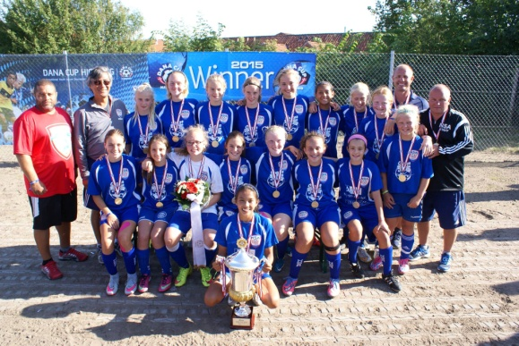

**The 23rd Annual NSA EUROTOUR was another very successful tour both on the field and off the field. Players from 7 nations played on NSA teams – USA, Sweden, Denmark, Germany, Australia, Belgium, Malta. The G13 composed of USA, Germany and Denmark players won the Dana Cup. It was a great cultural exchange experience through soccer for the participants.**

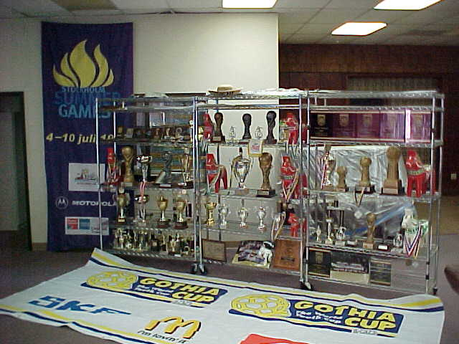**NSA's focus is on Youth Development** Since 1992, NSA has selected, trained and led over 2000 players and supporters on tour to compete in major International tournaments in Scandinavia, South America and the United States. To the credit of NSA players and coaches, after learning the NSA STYLE and the philosophy, players have consistently stepped up to the competition, as evidence by the **many championships** they have won. For **2016**, NSA is selecting serious players to compete in major International Tournaments and experience the time of their lives.