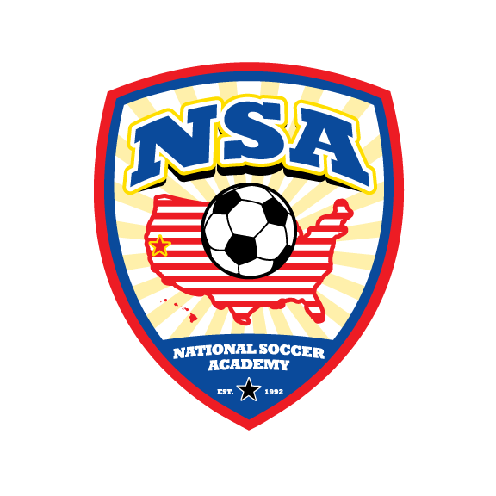 | National Soccer Academy  Clarkston Soccer Camp _2015  & Player Selection for EUROTOUR  June 8, 9,10,11 2015  Location: Walker Field 3211 4th St Lewiston, ID 83501 | 
Age & Skill Level Appropriate Training; Learn while having fun.

When: morning 9:00 - 12:00; afternoon 1:30-4:00; Lunch time will be supervised.
Cost: $195.00 Full Day $135- Half Day; all campers will receive one NSA Training T-shirt

Younger and beginning players 8 – 12 are encouraged to attend the morning session only.
Older and more advanced players ages 11 – 17 are encouraged to attend Full Day.
Morning sessions will focus more on technical skills.
Afternoon sessions will focus on small group and team tactics

All campers must wear an NSA Training T-shirt during the camp.
Additional Shirts may be purchased on site - $15.00 each

Head Instructor:
Fred Hsu Director of NSA,
USSF National “A” Licensed, Brazilian Coaching License, National Youth License, NSCAA Director of Coaching Diploma
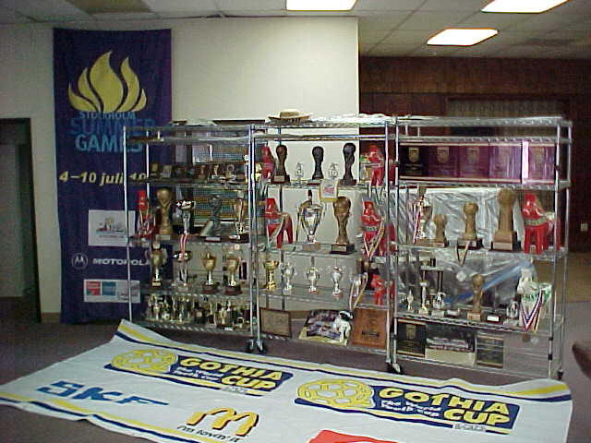
National Soccer Academy was founded in 1992 with a mission to provide opportunities for young players to learn, mature, and gain experiences via competition and cultural exchanges in major events nationally and internationally.
NSA has run soccer camps for over 10000 players and selected, and trained over 2000 motivated players to compete in major National and International tournaments.
This camp also serves as a tryout for the NSA EUROTOUR 2016.
contact: Brandon Bogar Valley Thunder Soccer club ph: 509-780-3547 em: bjcbogar@msn.com

Date: __________ NSA Medical Release Form Birthday ____________
Last name __________________________First name _____________________ male____female____

Email:__________________________________________________ Cell Phone:____________________

ADDRESS ____________________________ CITY ________________ STATE_____ ZIP________

Parents/Guardian names:________________________________E-mail______________________

List any Medical Problem or prohibition player has__________________________________________

Person to notify in emergency _________________________________ Phone ____________________

Physician to notify in emergency _______________________________ Phone ____________________

HEALTH & ACCIDENT INSURANCE PROVIDER _______________________________________
Number of years played ______ Last team __________________ Last League ___________________

I, ________________________________ , the parent/guardian of the registrant, a minor, agree that I and the registrant will abide by the rules of the National Soccer Academy (NSA), its affiliated organizations and sponsors. Recognizing the possibility of physical injury associated with soccer and in consideration for NSA accepting the registrant for its soccer programs and activities (the "Programs"), I hereby release, discharge and/or otherwise indemnify NSA, its affiliated organizations and sponsors, their directors, employees and associated personnel, including the owners of fields and facilities utilized for the Programs, against any claim by or on behalf of the registrant as a result of the registrant's participation in the Programs and/or being transported to or from the same, which transportation I hereby authorize. I also certify that my child is covered by primary health insurance for all injuries that may result from the "PROGRAMS".
CONSENT FOR MEDICAL TREATMENT (MINOR)
As the parent/legal guardian of the above-named registrant, I hereby give consent for emergency care prescribed by a duly licensed Doctor of Medicine or Doctor of Dentistry. This care may be given under whatever conditions necessary to preserve the life, limb or well-being of my dependent.

NAME____________________________ Signature:____________________________________
Parent/legal Guardian (Please Print)
Occupation:__________________________________
=====================================================================================
Player Name: ___________________________ Birthday: _____________________

Email: _________________________________ PHONE: ______________________
Shirt Size (circle one) : Adult Large || Adult Med || Adult Small || Youth Large|| Youth Medium

Register & pay online: at www.nationalsocceracademy.org or

Mail payment ( checks payable to NSA) with completed medical release form to :
NSA 26230 County Road 97, Davis, CA 95616 Enclosed check # ____ amount ______

