**NSA EUROTOUR memorabilia** 031214

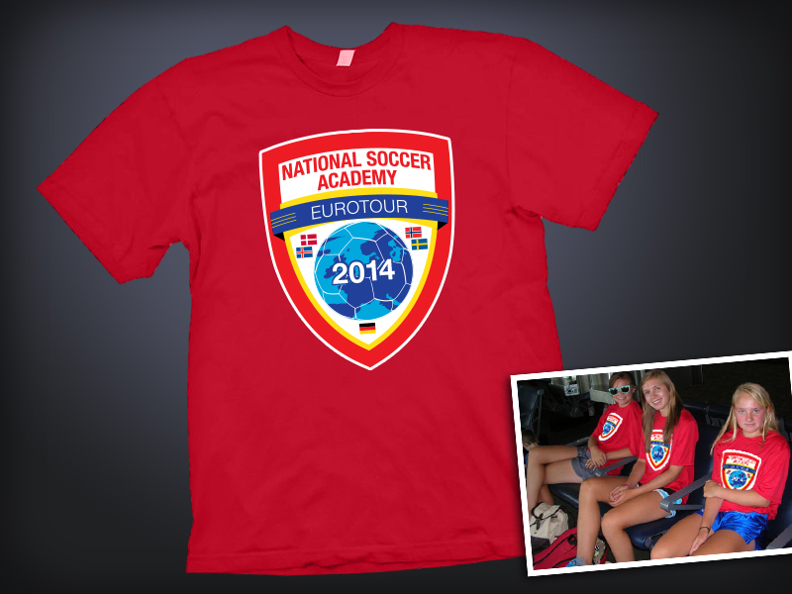To help preserve EUROTOUR 2014 memories, the following will be offered for EUROTOUR 2014.

1. **EUROTOUR Travel shirt**: every traveler (including adults) will receive **one EUROTOUR Travel shirt for free**.

Please go to

<http://www.anngroups.com/ann_selfassignmentsheetsrespond.phtml?gid=723>

and enter your shirt size. Players, we will use your jersey sizes.

Additional shirts may be ordered online at:

<http://www.anngroups.com/ann_shoppingcartpurchase.phtml?gid=713>

Orders must be place before March 31 2014.

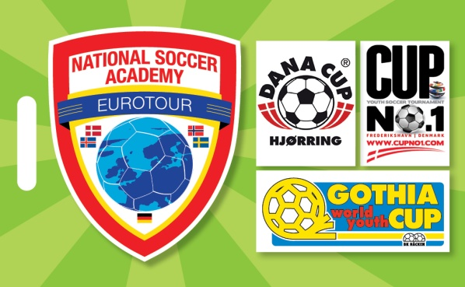

1. **NSA luggage tags**: every traveler will receive **two NSA luggage tags for free**.

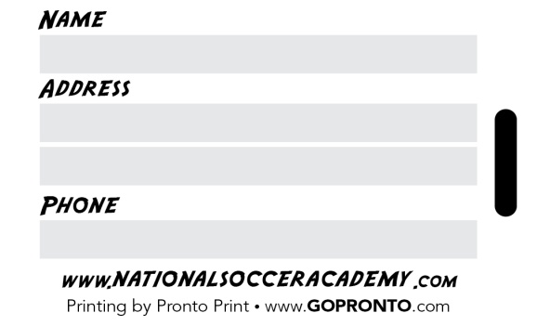Additional luggage tags (5.00) may be ordered at [ORDER NSA GEAR](http://www.anngroups.com/ann_shoppingcartpurchase.phtml?gid=713) <http://www.anngroups.com/ann_shoppingcartpurchase.phtml?gid=713>

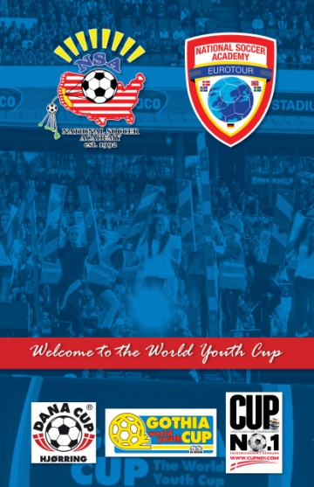

**EUROTOUR Journal** : every player will receive **one custom printed NSA journal for free**. Shown here is the front and back covers. There will be plenty of sheets for you to make entries about the matches, sightseeing and other memorable moments.

Additional journals ($22.00) maybe ordered at <http://www.anngroups.com/ann_shoppingcartpurchase.phtml?gid=713>

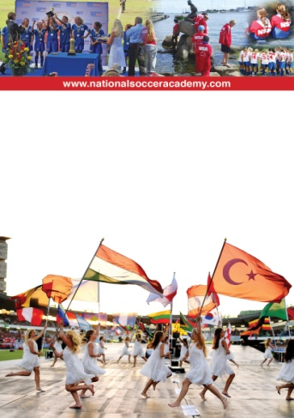

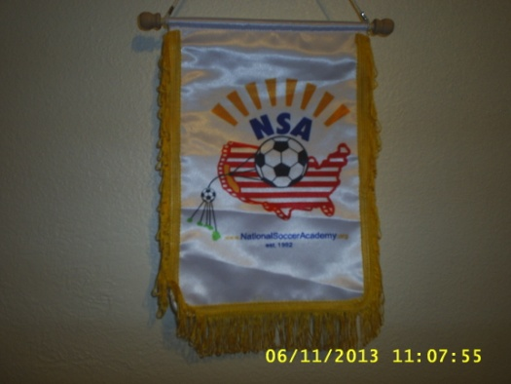

1. **NSA Pennants ($10.00)** : these pennants are used for the exchange with opposing teams in Europe. NSA provides the pennants for the game exchanges. You may also purchase them at <http://www.anngroups.com/ann_shoppingcartpurchase.phtml?gid=713>
2. **NSA Lanyards (5.00)** 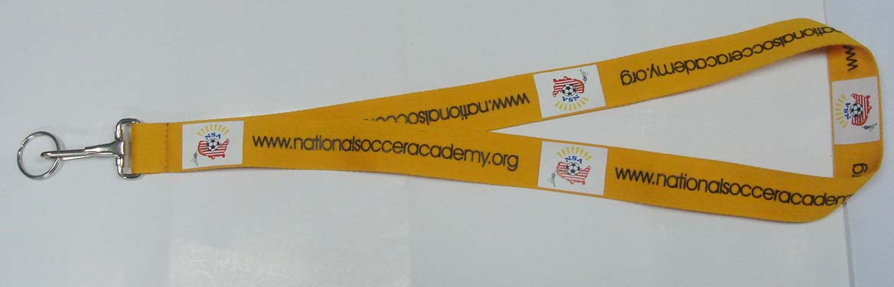

<http://www.anngroups.com/ann_shoppingcartpurchase.phtml?gid=713>

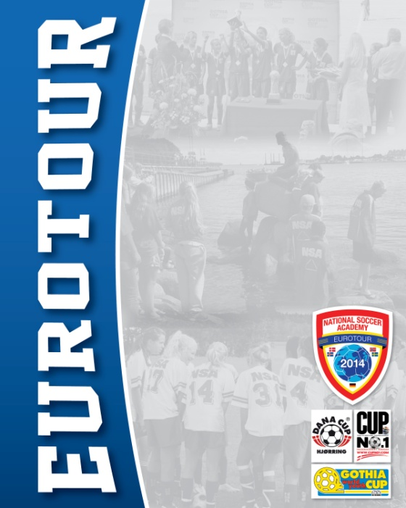

1. **NSA EUROTOUR 2014 picture book**: A considerable amount of effort and funds will be expended to custom produce the NSA EUROTOUR 2014 picture book. Many will contribute to the contents. Pronto Press will do the production. It will consists of lots of selected pictures and memorable moments write ups. This is a custom made product and the cost of production in small quantities is estimated to be over $100.00 each. If you place your online order prior to the May 31, **NSA will subsidize 50% so the cost to you will be 50.00. After May 31, you may still order at the full price.**

**Place your order now** at

[**http://www.anngroups.com/ann_shoppingcartpurchase.phtml?gid=713**](http://www.anngroups.com/ann_shoppingcartpurchase.phtml?gid=713)

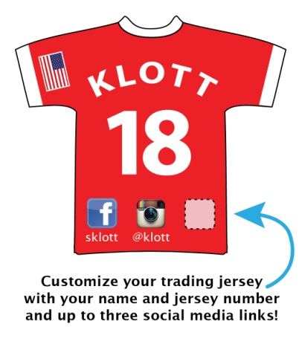

1. **Player JERSEY TRADER:** As a donation to NSA Players, Arnie has designed a custom Jersey Trader for all players. It will have the players name, jersey number, email and other contact info you wish to imprint. It will be about the size of a business card. The idea is for players to use them as “Calling Cards” when they meet new friends. Each player will receive 50 jersey traders for free (courtesy of Coach Arnie) . Additional “Jersey Traders” may be ordered by sending an email to Arnie Klott [arnie@gopronto.com](mailto:arnie@gopronto.com). $10- per 50.

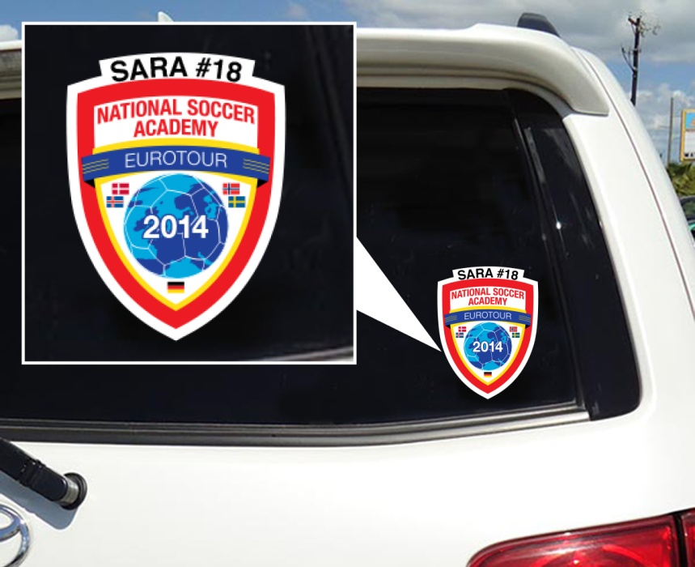

1. **Custom NSA Window Stickers:**  Arnie will print NSA logo Stickers for cars. Cost: 8.00 each. If you wish to add your own info, it will be 12.00 each. Please contact Arnie Klott Arnie Klott [arnie@gopronto.com](mailto:arnie@gopronto.com) directly .

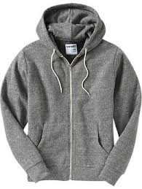

1. **Hoodies and other clothing** you wish to have the NSA logo embroidered:

We have received requests for Hoodies , jackets and other clothing with the NSA logo for supporters and players. Instead of trying to produce small quantities of all different types of garments, which is cost prohibitive, we have decided to facilitate the following:

1. You send us the garment you wish to have embroidered before April 15 2014 (this way, you buy the correct fit and colors).
2. We will send the garments to the Sports Shop to be embroidered. (Putting the NSA letters on the back will be optional).
3. To save on shipping cost, we will distribute the garments when we meet on July 5 or sooner.

**The cost of Embroidery and handling will be $25- per garment. You must include a check for payment with the garment made payable to NSA.**

1. 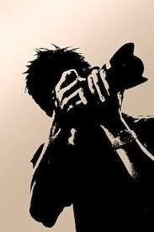**Photography services offered by ActionSnapper.net:** We have found from experience that although everyone seem to have a digital camera, it is more enjoyable to watch the events then to constantly peek through a small lens at the action.

One of the travelers Roy Rodriguez (Izze’s Dad) is a professional photographer and will offer his services to take great pictures of subscribers throughout the tour. If you wish to have a professional photographer pay special attention to you and your child during the tour and provide you with great digital photographs, you may order the service by emailing Roy directly **rrod1295@yahoo.com**.

**Some of Roy’s sample pictures will be posted on** [**www.**actionsnapper.net](http://www.actionsnapper.net) soon.

**Hire an Action Snapper for 3 weeks !**

Please complete the following form and email to Roy Rodriguez [rrod1295@yahoo.com](mailto:rrod1295@yahoo.com)

Feel free to call Roy 916-764-6690 to discuss.

**1Option A:** $350.00

* All rights and images of your child taken during Eurotour 2014.
  + Sightseeing
  + Practices
  + Games
* All images are unedited. At discretion of photographer some images may be edited and will be included with this option.
* All images are full resolution.
* Images can be downloaded or burned to CD/DVD or Flash Drive (please state your choice).

**Option B:** $30.00 per image

* All rights and images released to you.
* Select the images you want.
* Most images will be edited and cleaned up.
* Images can be emailed, downloaded or burned to CD/DVD or Flash Drive.

1Option A is limited to the first 15 families, with total paid before leaving on Eurotour2014