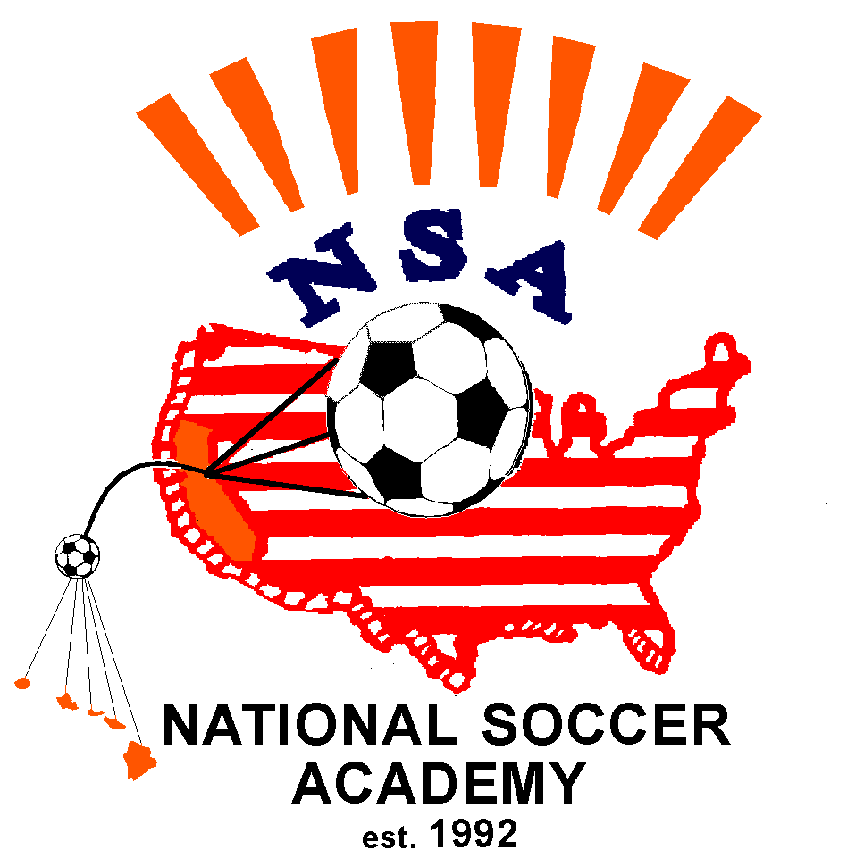www.nsasoccer.org
NSA is a non profit 501 (C ) (3) tax exempt corporation
email: info@nsasoccer.org
NSA Intense Training Week
Sponsored by the Glenwood Springs Soccer Club
Improve your play – join NSA

Age & Skill Level Appropriate Training by
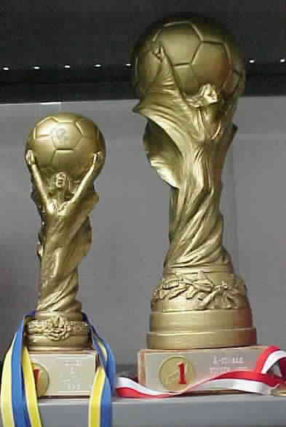

USSF & NSCAA Licensed Coaches

June 17-21, 2013 – Glenwood Park

Glenwood Springs, Colorado

Morning Training: 9:00 am – Noon Afternoon Training: 1:30 pm – 3:30 pm Supervised Lunch: Noon – 1:30 pm Boys and Girls ages 6 - 18

Space is limited, Register now

Learn the NSA Style that has won many international championships

*This also serves as a tryout for the NSA Eurotour 2014*
Directors:
Brad Jordan USSF “B” License, NSCAA Advanced National Diploma and Director of Coaching Diploma, multiple Youth Level Licenses, Director of Coaching – Glenwood Springs SC, Colorado Director for NSA, Staff Coach for NSA Eurotours, Former Semi-Pro & Collegiate player, 30+ years as a Club coach

Wayne Smith NSCAA National Diploma, USSF “D” License, NSCAA Goalkeeper Diploma, NSA Staff Coach, Assistant Director of Coaching – Glenwood Springs SC, Club coach

Name:_________________________ email:______________________________
Birthdate _______________ M___ F ____
Address: ___________________________ City _________ State___ Zip______
Phone: evening ______________ day ________________
NSA T-shirt (included): Size AL__ AM___ AS___YL___
Full Day__($ 200.00) Morning Only (rec. for 6-8 years, but not mandatory)__ ($120.00)
Please make payment to GSSC/NSA and attach with registration form.
check number_____________ payment______________
Mail to: Brad Jordan, PO Box 1031, Glenwood Springs, CO 81602
or use Online registration at www.nationalsocceracademy.org
Questions: Brad Jordan 970-947-1809; email-jordanarchitect@qwestoffice.net
You will receive medical release forms (downloadable or at field), directions to the fields and other information upon acceptance to the camp via e-mail and/or US Mail.
NSA players have won numerous International Tournaments since 1992 including the Gothia Cup (over 1200 teams from70 nations), Dana Cup, Stockholm Cup, Dalecarlia Cup, Oravais Cup and Coca-Cola Cup.
If your children are serious students of the game, they may be selected to join others to compete internationally and experience the time of their life.

Date: __________ NSA Medical Release Form Birthday ____________

Last name __________________________First name _____________________ male____female____

Email:__________________________________________________ Cell Phone:____________________

ADDRESS ____________________________ CITY ________________ STATE_____ ZIP________

Parents/Guardian names:________________________________E-mail______________________

List any Medical Problem or prohibition player has__________________________________________

Person to notify in emergency _________________________________ Phone ____________________

Physician to notify in emergency _______________________________ Phone ____________________

HEALTH & ACCIDENT INSURANCE PROVIDER _______________________________________

Number of years played ______ Last team __________________ Last League ___________________

I, ________________________________ , the parent/guardian of the registrant, a minor, agree that I and the registrant will abide by the rules of the National Soccer Academy (NSA), its affiliated organizations and sponsors. Recognizing the possibility of physical injury associated with soccer and in consideration for NSA accepting the registrant for its soccer programs and activities (the "Programs"), I hereby release, discharge and/or otherwise indemnify NSA, its affiliated organizations and sponsors, their directors, employees and associated personnel, including the owners of fields and facilities utilized for the Programs, against any claim by or on behalf of the registrant as a result of the registrant's participation in the Programs and/or being transported to or from the same, which transportation I hereby authorize. I also certify that my child is covered by primary health insurance for all injuries that may result from the "PROGRAMS". I acknowledge that NSA does not provide health and accident insurance for participants in any of its "PROGRAMS".

CONSENT FOR MEDICAL TREATMENT (MINOR)
As the parent/legal guardian of the above-named registrant, I hereby give consent for emergency care prescribed by a duly licensed Doctor of Medicine or Doctor of Dentistry. This care may be given under whatever conditions necessary to preserve the life, limb or well-being of my dependent.

NAME____________________________ Signature:____________________________________
Parent/legal Guardian (Please Print)

Occupation:__________________________________

