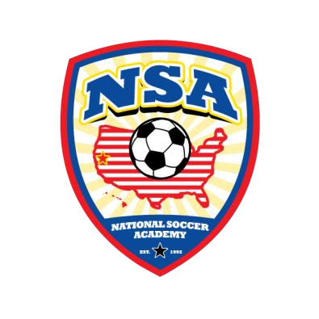**Elite Player Development Program**

**A better alternative for the selected few**

For Program Details, visit

<http://www.nationalsocceracademy.com/?page_id=2710>

**NSA is holding tryouts to select players to join the EPDP.**

**Spring Semester begins Feb 15, 2015 EPDP training will be held in the greater Sacramento area.**

Where & When: Feb 1 2015 3:00 - 4:00pm Field inside the Trac[k at Buljan Middle School](http://www.bing.com/maps/default.aspx?cp=38.73777%7E-121.2606&where1=Warren%20T%20Eich%20Intermediate%20School&ss=ypid.YN873x7863365013878995295&FORM=SNAPST)

100 Hallissy Drive Roseville, CA 95678

Who : For serious soccer players, boys and girls U13, U12, U1

Cost : 10.00 per one hour session

[**Online Registration and Payment**](http://www.getann.com/createaccount.phtml?cpn=774052) **at** [**www.nationalsocceracademy.org**](http://www.nationalsocceracademy.org/) • Players must come to the session DRESSED READY TO PLAY.

* 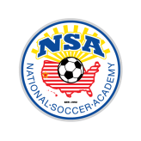Each session will consist of fun exercises and scrimmages conducive to players showing their abilities.
* Decision may be made after observing your player for one session.

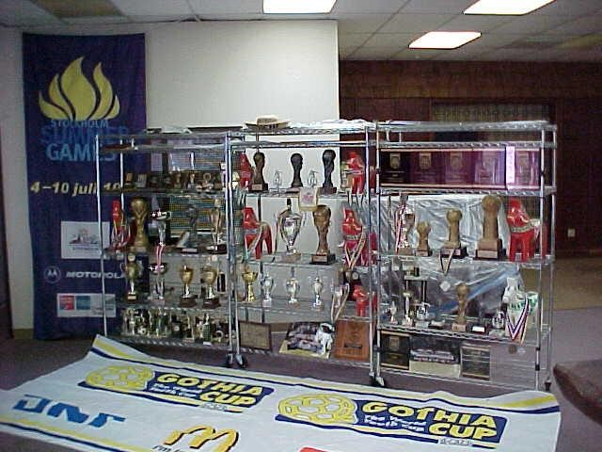

The EPDP program is for a small group of like

minded players who have passion to learn and

families who wish to have a better alternative for

their children

’s development.

Information meeting will be held at the field.

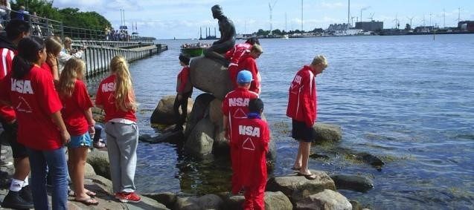

**Contact:**

**Fred Hsu 530-400-1903 nsaguru@gmail.com**

**Director of NSA; USSF “A” License, National Youth License, Brazilian Coaching License**

# NATIONAL SOCCER ACADEMY

A 501 (C ) (3) non profit Corporation, Davis, CA 95616 E-mail: info@nsasoccer.org website: **www.nationalsocceracademy.org**

Date: __________ NSA Member Registration Form **Birthday** _________

Last name __________________________First name _____________________ male____female____

Email:__________________________________________________ Cell Phone:____________________

ADDRESS ____________________________ CITY ________________ STATE_____ ZIP________

Parents/Guardian names:________________________________E-mail______________________

List any Medical Problem or prohibition player has__________________________________________

Person to notify in emergency _________________________________ Phone ____________________

Physician to notify in emergency _______________________________ Phone ____________________

HEALTH & ACCIDENT INSURANCE PROVIDER _______________________________________

Number of years played ______ Last team __________________ Last League ___________________

I, ________________________________ , the parent/guardian of the registrant, a minor, agree that I and the registrant will abide by the rules of the National Soccer Academy (NSA), its affiliated organizations and sponsors. Recognizing the possibility of physical injury associated with soccer and in consideration for NSA accepting the registrant for its soccer programs and activities (the "Programs"), I hereby release, discharge and/or otherwise indemnify NSA, its affiliated organizations and sponsors, their directors, employees and associated personnel, including the owners of fields and facilities utilized for the Programs, against any claim by or on behalf of the registrant as a result of the registrant's participation in the Programs and/or being transported to or from the same, which transportation I hereby authorize. I also certify that my child is covered by primary health insurance for all injuries that may result from the "PROGRAMS". I acknowledge that NSA does not provide health and accident insurance for participants in any of its "PROGRAMS".

CONSENT FOR MEDICAL TREATMENT (MINOR)

As the parent/legal guardian of the above-named registrant, I hereby give consent for emergency care prescribed by a duly licensed Doctor of Medicine or Doctor of Dentistry. This care may be given under whatever conditions necessary to preserve the life, limb or well-being of my dependent.

NAME_________________________________________ Signature:____________________________________

Parent/legal Guardian (Please Print)

Occupation:__________________________________

# NATIONAL SOCCER ACADEMY

A 501 (C ) (3) non profit Corporation, Davis, CA 95616 E-mail: info@nsasoccer.org website: **www.nationalsocceracademy.org**