The NATIONAL SOCCER ACADEMY presents:  RENO Soccer Camp 2015  & Player Selection for EUROTOUR  Dates: June 23-26, 2015  Location: South Valley Soccer Complex  15650 Wedge Pkwy Reno, NV, 89511 | 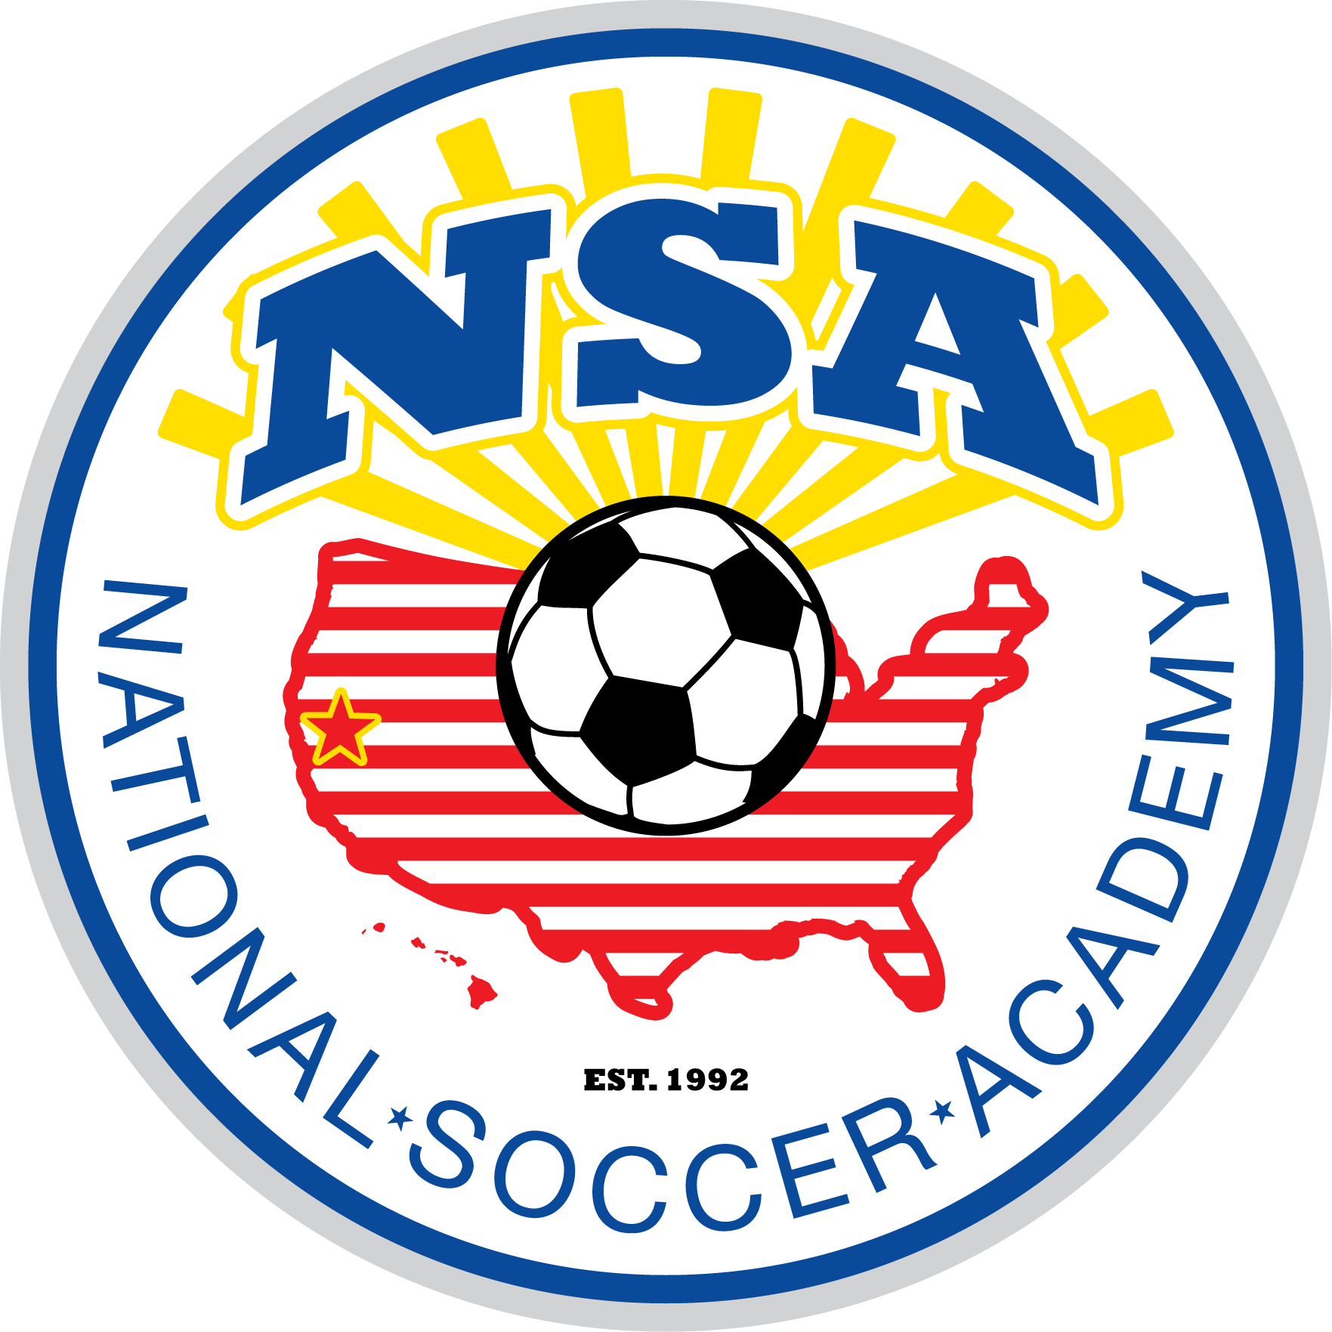
Learn While Having Fun! Age & Skill Level Appropriate Training.
Schedule/Sessions:  - Morning Session: 10:00am-12:00pm  Cost (includes NSA Training T-shirt):  - $135 | Half Day  Afternoons are reserved for Team Training. We are taking reservations from Coaches and Directors of Clubs for their top tiered teams who wish to have additional training on team tactics. Contact Coach Fred.  Advanced players may join also.  - Cost 135- per player | Afternoon Team Training  Program Notes:  - Younger and beginning players 8-12 are encouraged to attend the morning session only.  - Older and more advanced players ages 11-17 are encouraged to attend Full Day. Morning sessions will focus more on technical skills. Afternoon sessions will focus on small group and team tactics.  - All campers must wear an NSA Training T-shirt during the camp. Additional shirts may be purchased on site at $15 ea.  - NSA camp staff will also be looking at players who are interested in attending EuroTour 2016. More information can be found at www.nationalsocceracademy.com | 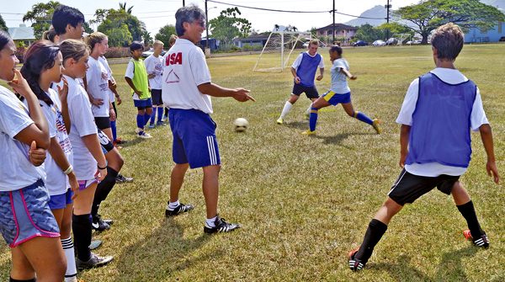  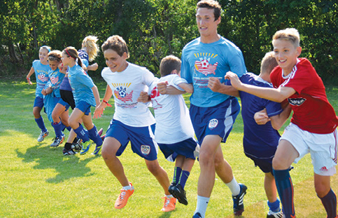  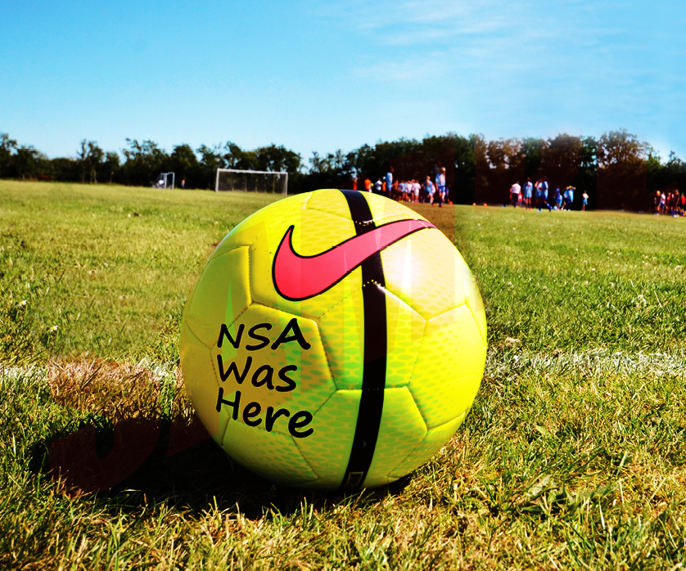
About NSA:  National Soccer Academy was founded in 1992 with a mission to provide opportunities for young players to learn, mature, and gain experiences via competition and cultural exchanges in major events nationally and internationally. NSA has run soccer camps for over 10000 players and selected, and trained over 2000 motivated players to compete in major National and International tournaments.  This camp also serves as a tryout for the NSA EUROTOUR 2016. |   Fred Hsu:  Director of NSA  & Camp Head Instructor  USSF National “A” Licensed, Brazilian Coaching License, National Youth License, NSCAA Director of Coaching Diploma.
NSA Medical Release Form:
Date: __________ Birthday ____________
Last name _________________________________ First name _____________________ male____female____
Email:__________________________________________________ Cell Phone:______________________________
Address ____________________________ City___________________________________State_____ ZIP________
Parents/Guardian names:________________________________ E-mail___________________________________
List any Medical Problem or prohibition player has___________________________________________________
Person to notify in emergency _________________________________ Phone _____________________________
Physician to notify in emergency _______________________________ Phone _____________________________
HEALTH & ACCIDENT INSURANCE PROVIDER _____________________________________________________
Number of years played ______ Last team _______________________ Last League _______________________

I, ________________________________ , the parent/guardian of the registrant, a minor, agree that I and the registrant will abide by the rules of the National Soccer Academy (NSA), its affiliated organizations and sponsors. Recognizing the possibility of physical injury associated with soccer and in consideration for NSA accepting the registrant for its soccer programs and activities (the "Programs"), I hereby release, discharge and/or otherwise indemnify NSA, its affiliated organizations and sponsors, their directors, employees and associated personnel, including the owners of fields and facilities utilized for the Programs, against any claim by or on behalf of the registrant as a result of the registrant's participation in the Programs and/or being transported to or from the same, which transportation I hereby authorize. I also certify that my child is covered by primary health insurance for all injuries that may result from the "PROGRAMS".
CONSENT FOR MEDICAL TREATMENT (MINOR)
As the parent/legal guardian of the above-named registrant, I hereby give consent for emergency care prescribed by a duly licensed Doctor of Medicine or Doctor of Dentistry. This care may be given under whatever conditions necessary to preserve the life, limb or well-being of my dependent.

NAME____________________________________ Signature:____________________________________________
Parent/legal Guardian (Please Print)
Occupation:__________________________________________

Player Name: _____________________________ Birthday: _____________________

Email: _________________________________________________ PHONE: _______________________________
Shirt Size (circle one) : Adult Large || Adult Med || Adult Small || Youth Large|| Youth Medium
Register & pay online: at www.nationalsocceracademy.org or
Mail payment ( checks payable to NSA) with completed medical release form to :
NSA 26230 County Road 97, Davis, CA 95616 Enclosed check # _______ amount ________

