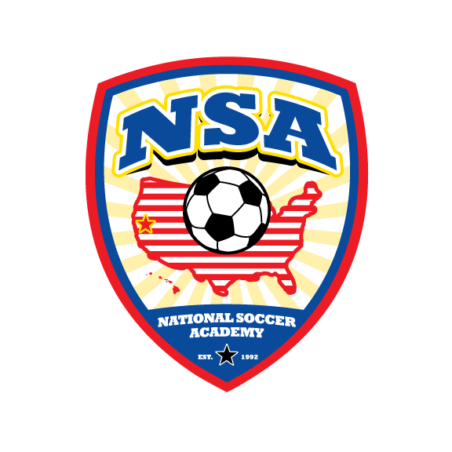**NSA’s mission is to teach and create excellent learning environments for soccer players and families**

NSA is now assembling tournament teams to compete in the

**Northern Nevada Mayors Cup , Reno NV June 13th & 14th 2015.**

We are selecting Boys and Girls born after 8/1/2001 (U13, U12, U11)

Several tryout/training sessions will be held prior to the event in Davis, CA. Cost is the normal $40- per session. Visit [www.nationalsocceracademy.org](http://www.nationalsocceracademy.org) for dates, location and registration.

**For each tournament, cost per player: $395.00** includes:  
195 - Tournament fees and Team Organization  
125 - Coaches Wages

75 - Coaches Travel, Lodging and Food

These tournament teams are by invitation only.

Commitment to the tournament has to be made by May 5, 2015.

If you are interested and available, please email coach Fred immediately ([nsaguru@gmail.com](mailto:nsaguru@gmail.com)) and come to the next training sessions.

We will only bring 11 – 14 player on each team.

Other costs:

Playing uniforms $115-   includes 2 jerseys (35- each)  1 pair of shorts (25-) 1 pair of socks (20).

Please visit <http://www.nationalsocceracademy.com/?page_id=1447>

Coach Fred

[nsaguru@gmail.com](mailto:nsaguru@gmail.com)

**Strive For Excellence, Enjoy The Process, Good Results Will Follow**