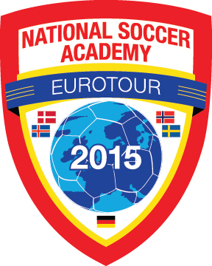  . | EUROTOUR 2015  Memory Picture Book  A momento for a life time | 
For EUROTOUR 2014, Coach Arnie Klott spent countless hours over a 6 month period to select from over 20000 pictures to create the memory book. You may view the memory book for 2014 EUROTOUR at http://www.loveofthegame1.com/eurotour_book.php
Testimonials from participants - EUROTOUR 2014.
- Arnie, I received the book. It is beautifully put together. Very well done. I wish I could have been there but since I couldn't this made me feel like I was.
- Dear Arnie,
Thank you so much for all the effort, energy, time and creativity that you put into making the photo book.
You did a fantastic job!!!
When Dylan opened it he was thrilled.
Thank you for creating such a great memory book for all of these players. They will treasure it always
- I want to compliment you and your folks on the memory book. It turned out terrific! What an awesome keepsake for the kids!
- Hey Arnie!! Yes we got it and it was incredible! It was much more than we anticipated, you did an awesome job. We immediately opened it and looked through it together.
- Hi Arnie, just received the memory book and, omg, I can't stop going thru pages, over and over again. It is wonderful, thank you so much for doing such amazing job. I can see you put a lot of effort into it.
- Hi Arnie! We received the memory book and Pey and I had a chance last night to look at it together as well as the booklet with Facebook postings.
It brought back great memories and we found ourselves laughing quite a bit! This is something both of us will cherish for years to come.
Thank you so much for the time you spent putting this together - it's perfect!
- Hi Arnie! I just now had time to look at the amazing book you put together! It really captures the trip and all the great memories. I know it was a huge labor intensive project. Tell your layout designer that he did a great job, too.

For 2015, we have a more efficient process to create the 2015 EUROTOUR memory book.
- Players and Supporters may each upload up to 30 pictures with caption they would like to see in the memory book via the link http://gopronto.com/eurotour-photo-book-2015
- Arnie will be the editor and select what he needs to create the picture book.
- All orders, payments and delivery will handled by GoPronto.com
- All communications should be directed to Arnie Klott arnie@gopronto.com, owner of GOPRONTO.com located in Medford Oregon.
- The cost of the 2015 memory book is $120- plus shipping and handling if pre-ordered prior to the tour. ORDER NOW!
- The cost of the memory book will be $180- plus shipping if ordered after July 20, 2015.
ORDER NOW and save at http://gopronto.com/eurotour-photo-book-2015

