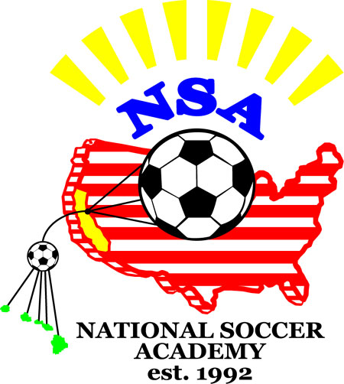
Congratulations! 9/19/2013
You have been invited to join the NSA Tournament Teams to participate in the FC Elk Grove Thanksgiving Tournament 2013
Event Dates: 11/30/2013-12/1/2013
The playing format for U11G is 8 v 8. We plan to bring between 8 to 10 players.
It takes cooperation from all invited families to make this a successful event. NSA forms tournament teams with just enough players of the appropriate playing level. It is critical that everyone honors their commitment for the weekend.

The cost for the tournament weekend is as follows :(per player cost)
Tournament Fees | 65
Team Organization | 70
Coaches wages (10 hrs *15) | 150
Coaches Travel & Lodging | 75
 | 360
Uniforms: for new participants, NSA Jerseys Blue (30.00) , NSA Jerseys White (30.00) NSA logo shorts (25.00) and NSA logo socks (20.00).

Families are responsible for their own travel, food and lodging. All players will stay at the same hotel unless you have family close by. If the NSA Club house is available, we may be able to house the kids in Davis.

Players will be using US Club Soccer Passes. You should contact Roy to register with NSA. Roy Rodriguez roy@nsasoccer.org 916-764-6690 is our Administrator and will coordinate the hotel arrangements and player passes.

For the tournament team, there will be an intense Team Training/ weekend on Nov 23/14 2013. Details will be forthcoming. Training cost for the weekend is $70.00. We would like ALL tournament team players to participate. Team tactics will be emphasized during the training sessions to prepare for the competition.
Other Training: We encourage players to come to the periodically scheduled NSA training sessions to learn and join the fun but they are not mandatory. Cost is $35- per session.

Please confirm your acceptance immediately via return email and pay online at http://www.anngroups.com/ann_shoppingcartpurchase.phtml?gid=713
We need to have at least 8 confirmed before we apply and we are up against the deadline.
You may also mail a check to NSA 26230 County Road 97, Davis, CA 95616
If we ended up not attending, your fees will be refunded.

NSA reserves the right to replace players if we do not hear from you in a timely manner

Coach Fred
Director, NSA
TOUR

The NSA teams stay together the whole time. Activities will be planned.
Supporters must not take their children on side trips unless cleared with the Director of NSA.

Medical:

If you are less than 100% physically fit prior to departure for the trip, it is your responsibility to contact NSA prior to leaving home. Any decision on your travel must be made after consultation with the NSA Director.

Equipment:

You are responsible for all soccer equipment including shoes. Remember to bring along any additional items that you normally use for training or games, such as tape, water bottle, shin guards etc.

Accommodations & meals:

Cost of the accommodations and meals will be paid by the players (or parents present).
Accommodations will be in a tournament recommended hotel. We recommend families share rooms so players can be together as much as possible. All that is required is at least one adult in the room. This provides supporters more flexibility and more opportunities for all NSA families to become buddies.

Refunds:

To enable a successful tour, we must have serious players with families wishing to make a major commitment.
There are no refunds unless the team does not come together for the event.

SUPPORTERS:
Supporters are welcome. Please read the sheet title "Helpful hints for NSA supporters".

There are many details that need to be planned in order for this tour to be successful. It is crucial that you follow our schedule. Please communicate openly and in a timely manner with us if you have any questions.

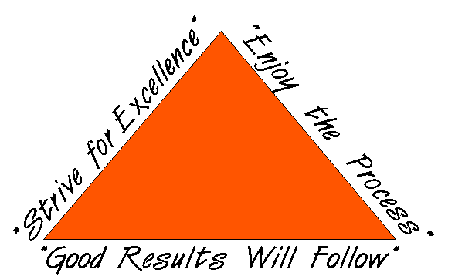

BE FLEXIBLE
We will work together to make this an enjoyable experience for your children.

Documents to Complete

This section contains forms that must completed and other required items to complete the Registration Process:

___ Code of Conduct - This document explains the expectations of the player's conduct. It is a contract between the player and -the coaches, parents, teammates and officials. It spells out the disciplinary basis of the tour. One (1) original document required.

___ NSA Medical Release Form (if you have not done so).

___ Health Insurance Card - One (1) copy required.

If the player is registered with US Club Soccer for the current season with a club other then NSA, the following is required:

_____ US Club Soccer Player Passcard – One (1) copy – front and back*,

_____ US Club Soccer Player Loan Form – Completed as instructed on form*

* Original Player Passcard and US Club Soccer Player Loan Form are required for all players registered with US Club Soccer through a club other than NSA.
- Bring the player pass to the tournament with a copy of the signed loan form.

If the player wish to Register (or Dual Register) with NSA with US Club Soccer. The following is required:

______ Proof of Birth (copy of Birth Certificate, Passport, etc.)

___ One photo (face shot , approximately 1 X 1) - Write full name on back of photos. Digital pictures are OK.

Please Contact the NSA Registrar for assistance.

NSA will register and obtain a player pass card for you from U.S. Club Soccer.

email digital picture  to /NSA | Code of Conduct  National Soccer Academy
Name_________________________________ Birthday ________________
The following is a list of rules and regulations that will be enforced by the director, administrators and coaches of the National Soccer Academy. All players who participate in NSA events and tours are subject to these rules. This document requires signatures from the player and parent/guardian(s). Please read, sign, and return the original.

1. Possession by any player of pocket knives, guns, fire-crackers, firearms, alcoholic beverages, drugs (un-prescribed or illegal), other weapons, or related paraphernalia will result in immediate expulsion from the National Soccer Academy event/tour.

2. Unauthorized visits to rooms/houses by members of the opposite sex, incidents of stealing or vandalism, unauthorized absences from any practice, game or group function, or failure to inform officials of your destination, may result in disciplinary action and/or expulsion from the event/tour.

3. Players must always be in the presence of staff personnel or assigned chaperones, unless specific approval is obtained. While on tour the curfew for players shall be 9:00 p.m. Quiet time will be designated until the mandatory lights out time (between 10:00 p.m. to 11:00 p.m.).

4. Any action that could threaten the health and safety of individuals or group members may result in immediate expulsion.

5. Arrest and detention by a government official (local or foreign) will result in immediate expulsion from NSA. Parent(s)/Guardian(s) assume immediate responsibility should a player be detained by a government official for any reason.

6. When necessary, searches of rooms and belongings may be carried out by tour officials without prior approval of the players. In most cases, players will have the opportunity, without penalty, to turn in any incriminating items before the search.
7. Repeated minor violations (such as disrespect for coaches, staff, players, use of tobacco, cigarette lighters, toy guns and water pistols, or profanity) may also result in expulsion.

I/We have read the above, understand and agree to the National Soccer Academy’s Code of Conduct. I/We agree to honor the above agreements and commitments. As a player, I will actively listen, treat others the way I would have them treat me, and agree to always acknowledge and respect the National Soccer Academy, it’s coaches, administrators, players and other officials.

Player’s Signature ____________________________________ Date __________
I/We acknowledge that no refunds are given in the event of expulsion for disciplinary reasons, and that I/we as a parent/guardian are responsible for any additional costs (including phone calls, hotels, air/ground transportation, etc) involved in sending my child home. I/We acknowledge that I/we will be notified immediately in the event of major disciplinary problems, before action is taken.

Parent’s /Guardian Signature ____________________________________ Date __________
NSA rule: no eating candy except on Saturdays
Helpful Hints for NSA Supporters

NSA players travel as a ‘tight’ family. The tour leader, the coaches and administrators manage players. Soccer is the focus of the player group.

Following are some hints:

On the Field:
- Enjoy the matches, video tape them, take lots of pictures, enjoy the atmosphere, cheer for the team, make friends with people from around the world. Leave your children and other players alone so that they grow from their experience.
- Never tell an NSA coach how to coach. The NSA staff are professional coaches - trust their instincts and experience regarding the game of soccer. Look to the “process” of development (the big picture) for achievements, not simply the scores of the matches or the amount of time your child is present on the field. Judging from the players who have trained and traveled with NSA, the NSA coaches have been very successful in treading the fine line of helping a child develop the “performance” part of their game without undue pressure during these tours. NSA does not and will not condone the “win at all cost” mentality. However, do not send your child with us if you cannot accept the coaches’ decisions as to who represents NSA during matches.
- “Performance” is emphasized during these tours -- not the amount of time a player is present on the field during matches. NSA staff coaches will do what is best for the teams to enhance “performance”.
- During tournament competition, the best players at that time will represent NSA on the field. Substitutions will be made due to
a) Injury;
b) Player’s performance;
c) Tactical changes for the match
d) Scores are lop-sided.

- We create the “performance” environment and enable players to play as much as possible
To increase the amount of possible “match” time for all our players, NSA brings “just enough” players. . However, there is absolutely no guarantee on the amount of “match” time for any player. Parents of players participating on the tour must accept the NSA coaches’ judgment regarding who represents NSA at the matches.

Off the field:
- Sightsee with friends and other supporters. Relax and have a fun time. Leave your children with the NSA staff so they become independent and enjoy the soccer tour atmosphere.
- Offer to help with laundry. That has always been a big job.
- All players must stay with the tour. You child must never be isolated from the other players (unless he/she is sick).
Supporters are not allowed to take their children away from the group without prior approval from the tour leader. Should the opportunity arise, you may take your child for a brief period of time. However, your child must invite at least three other players and go with you as a group.

A Good NSA tour supporter
- Does not have unrealistic ideas about their child’s ability.
- Is very flexible. Traveling on soccer tours can be very stressful to some.
- Does not have unrealistic expectations from the tour.
- Does not “cling” to your children during the tour

Date: __________ NSA Medical Release Form Birthday _________

Last name __________________________First name _____________________ male____female____

Email:__________________________________________________ Cell Phone:____________________

ADDRESS ____________________________ CITY ________________ STATE_____ ZIP________

Parents/Guardian names:________________________________E-mail______________________

List any Medical Problem or prohibition player has__________________________________________

Person to notify in emergency _________________________________ Phone ____________________

Physician to notify in emergency _______________________________ Phone ____________________

HEALTH & ACCIDENT INSURANCE PROVIDER _______________________________________

Number of years played ______ Last team __________________ Last League ___________________

I, ________________________________ , the parent/guardian of the registrant, a minor, agree that I and the registrant will abide by the rules of the National Soccer Academy (NSA), its affiliated organizations and sponsors. Recognizing the possibility of physical injury associated with soccer and in consideration for NSA accepting the registrant for its soccer programs and activities (the "Programs"), I hereby release, discharge and/or otherwise indemnify NSA, its affiliated organizations and sponsors, their directors, employees and associated personnel, including the owners of fields and facilities utilized for the Programs, against any claim by or on behalf of the registrant as a result of the registrant's participation in the Programs and/or being transported to or from the same, which transportation I hereby authorize. I also certify that my child is covered by primary health insurance for all injuries that may result from the "PROGRAMS". I acknowledge that NSA does not provide health and accident insurance for participants in any of its "PROGRAMS".

CONSENT FOR MEDICAL TREATMENT (MINOR)
As the parent/legal guardian of the above-named registrant, I hereby give consent for emergency care prescribed by a duly licensed Doctor of Medicine or Doctor of Dentistry. This care may be given under whatever conditions necessary to preserve the life, limb or well-being of my dependent.

NAME____________________________ Signature:____________________________________
Parent/legal Guardian (Please Print)

Occupation:__________________________________

NATIONAL SOCCER ACADEMY
A 501 (C ) (3) non profit Corporation
Davis, CA 95616
E-mail: nsaguru@gmail.com website: www.nationalsocceracademy.org

Player Loan Form
Use this form to loan a player between two US Club Soccer members.

Directions:

1. Club #2 (club obtaining the player) initially completes their portion of the form and sends it to Club #1 (club loaning the player).

2. Club #1 completes and signs their portion of the form, returns it to club #2, and gives a copy to the player, along with his current US Club Soccer player’s card.

3. Club #1 is also responsible for sending a copy of the completed form to US Club Soccer as set forth below.

Note: it is not necessary to receive US Club Soccer’s approval of this loan as long as a copy of the loan form and a valid player card accompany the player to the competition; and a copy is sent to US Club Soccer.

Note: the player’s insurance coverage applies only if Club #1 submits a copy of the completed document to US Club Soccer in one of two ways:

- Mail with a postmark prior to the competition start date to: US Club Soccer, Attn: Player Loan, 716 8th Ave. N, Myrtle Beach, SC 29577; OR
- Email a scanned version of a completed, signed document prior to the start of competition to: admin@usclubsoccer.org
- DO NOT fax this form.

Please print clearly Today’s Date:
Player’s Name: |  |  |  | Expiration Date:
Player’s Identification Number (as shown on card):
Player’s Date of Birth |  |  | Jersey #:

Date(s) for loan of player: | Nov 30 – Dec1 2013
Name/Location of Event: | Elk Grove Thanksgiving Tournament
Date(s) of Event: | Nov 30 – Dec 1 2013

Club #1 Club loaning player:
Team Name: | Team Identification #:
Club Rep. Signature: |  | Club Fax #
Signature Position Print Name

Club #2 Club receiving player: National Soccer Academy
Team Name: | Team Identification #:
Club Rep. Signature: |  | Club Fax #
Signature Position Print Name

